Practical - 12
Practical Title: 12: Event Management CRUD with Poster Upload and File Validation

Problem Definition: Develop event management functionality for admin users. Admin can add,

view, update, delete, and upload event posters with file type and file size

validation.

Theory

1. Are add, update, and delete functionalities implemented correctly?
ANSWER: Yes, the CRUD operations are implemented to add new events, update existing event details, display event records, and delete events. The changes are reflected in the MySQL database.

2. Is the UI linked with the database correctly?
ANSWER: Yes, the PHP interface is connected to the MySQL database using mysqli. Event details are inserted, retrieved, updated, and deleted through SQL queries.

3. Are poster uploads validated for type and size?
ANSWER: Yes, server-side validation checks the uploaded file's type and verifies that it is a valid image. Only JPG, PNG images up to 2 MB are accepted.

4. Are success and failure messages displayed?
ANSWER: Yes, success messages are displayed after successful CRUD operations. Error messages are displayed for invalid file uploads and failed operations.

Implementation/ Output/Result:

Evidence of Work (Screenshots):

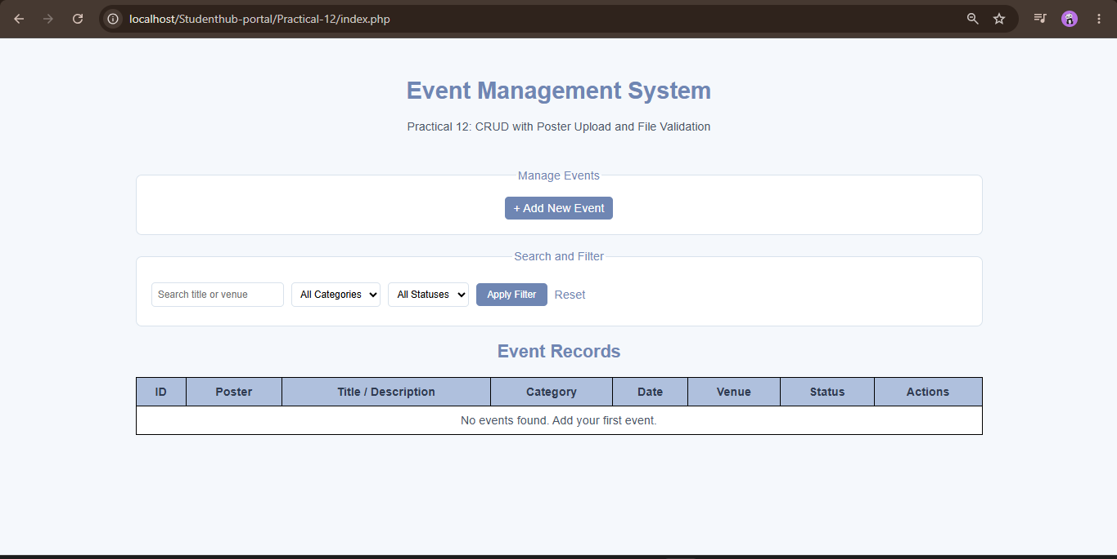

Adding a new event:
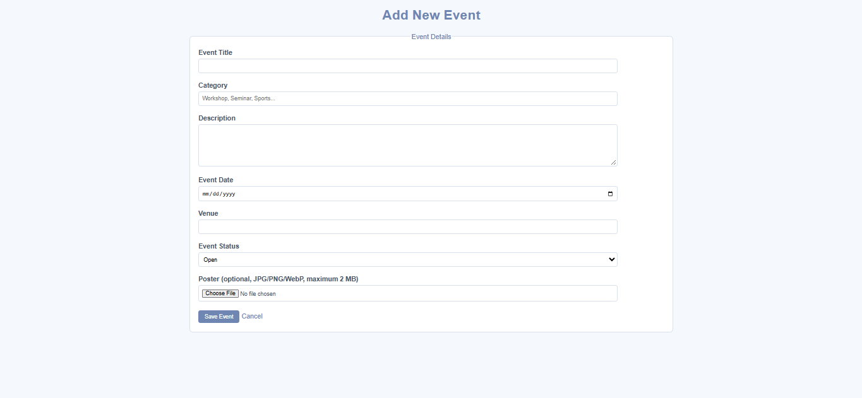
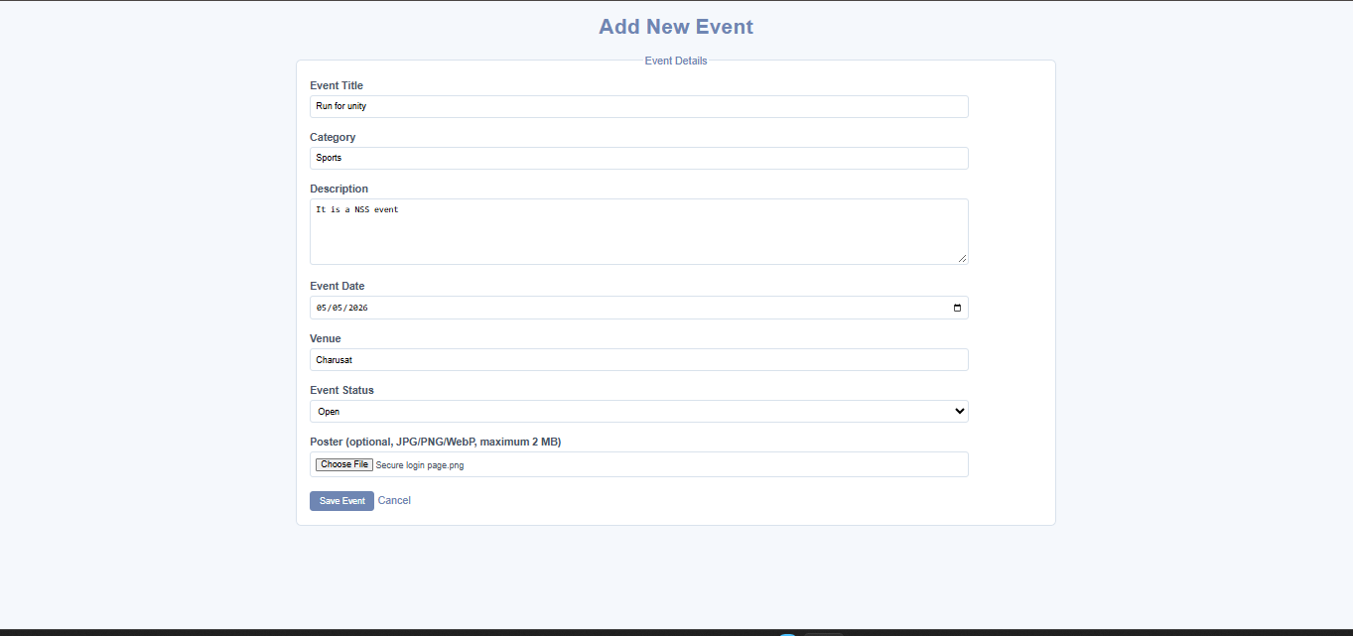
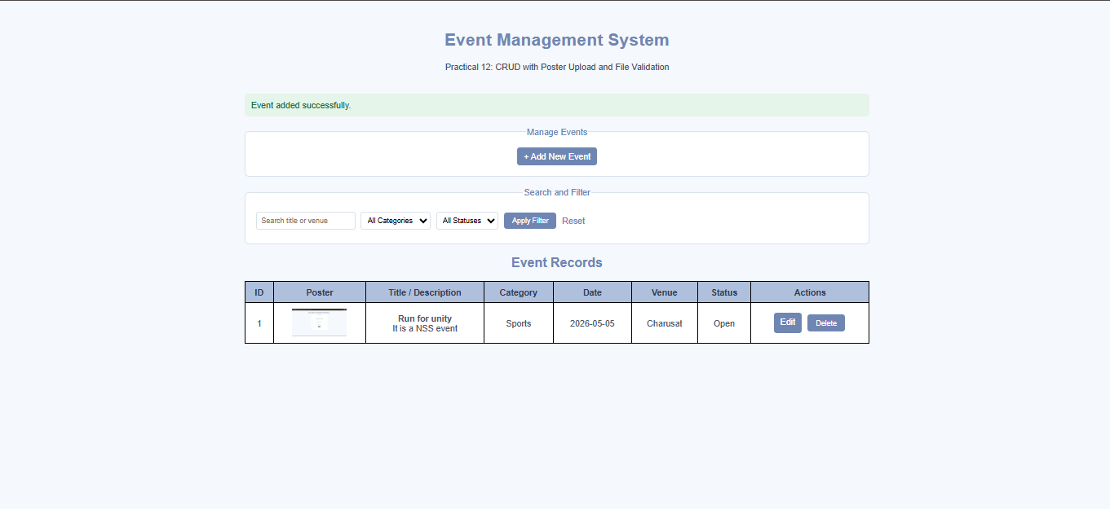

Searching event by venue:
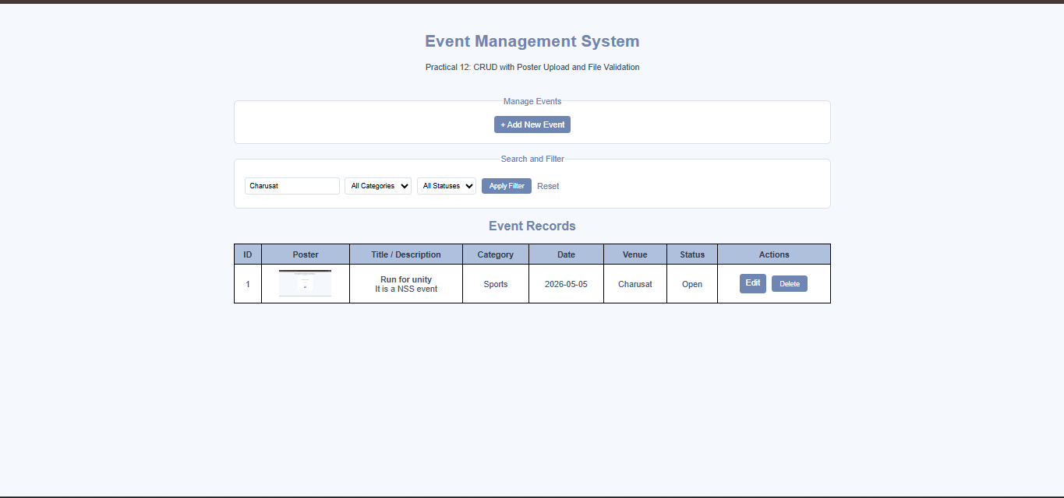

Deletion of an event:
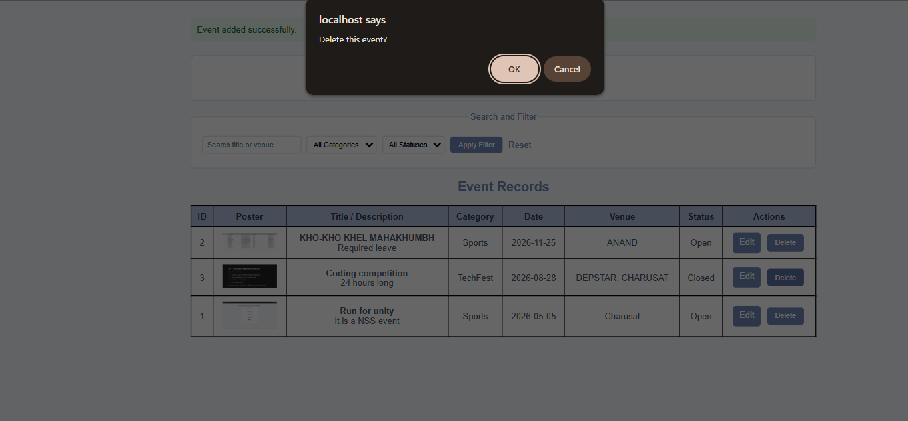




Database:
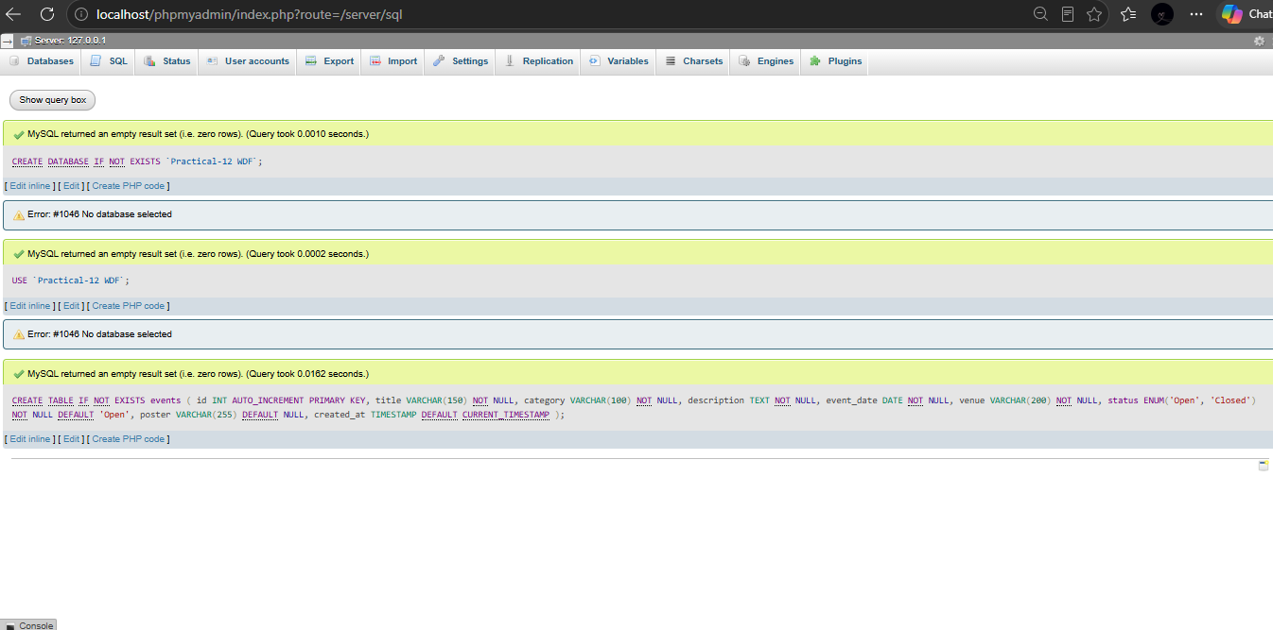
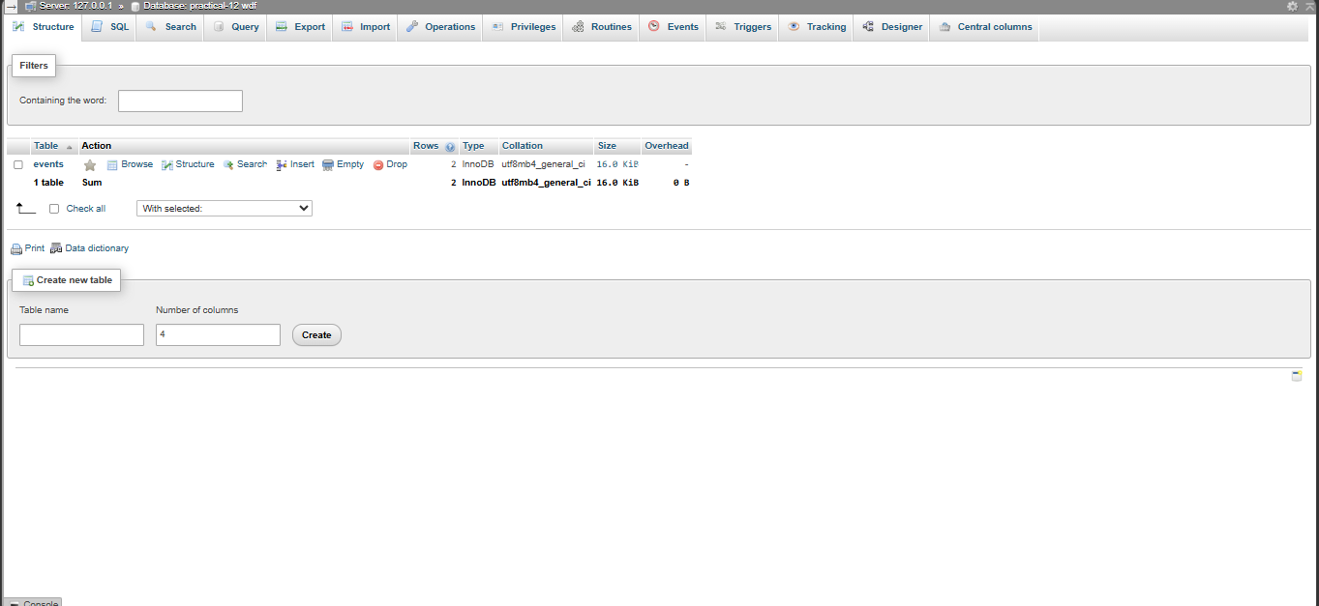
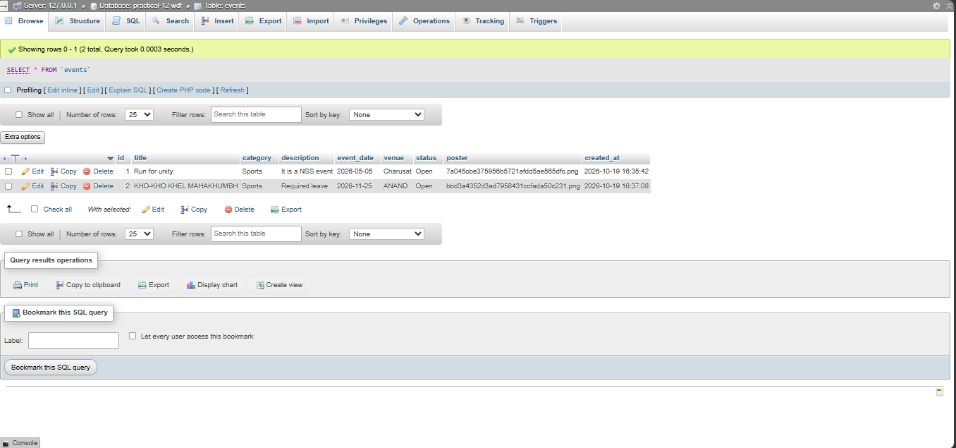

GitHub Repository Link:

https://github.com/shiloni28/WDF.git

E.Challenges Faced:

• Linking the PHP pages with the correct database and table.
• Handling poster uploads using multipart/form-data.
• Validating image file types and restricting the maximum file size to 2 MB.
• Displaying uploaded posters correctly from the uploads directory.
• Updating event details without accidentally removing the existing poster.
• Handling invalid file uploads and displaying appropriate error messages.
• Ensuring that database changes are reflected correctly in the dashboard.
• Managing file paths and stylesheet links within the existing project structure.

F.Learning Outcomes:

- Learned to implement CRUD operations using PHP and MySQL.
- Learned to connect a PHP application with a MySQL database using mysqli.
- Understood how to upload and store event poster images on the server.
- Learned to validate file types, image formats, and file sizes.
- Understood how to use prepared statements to execute database queries securely.
- Learned to implement search and filtering by event category and status.
- Understood how to update event details while retaining or replacing an existing poster.
- Learned to display success and error messages based on operation results.

Faculty Remarks:

